**Comparing Respiration**

Multiple Choice

1. Define the operculum.
2. A protective cover over the gills.
3. Holds the gill filaments.
4. The site of gas exchange.
5. A respiratory organ.
6. Define gill filaments.
7. The site of gas exchange.
8. Holds the gill filaments.
9. A protective covering over the gills.
10. A respiratory organ.
11. Define a gill.
12. The tail of aquatic animals.
13. A protective cover over the gills.
14. Respiratory organ of land animals.
15. The respiratory organ of aquatic animals.
16. Define the gills arch.
17. The site of gas exchange.
18. The respiratory organ of aquatic animals.
19. The protective covering over the gills.
20. Holds the gill filaments.
21. Identify the name of the structure indicated by the red line in the picture below.

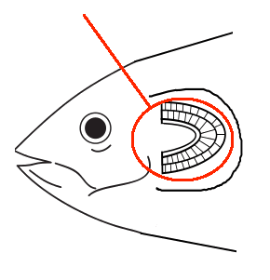

1. Gill
2. Operculum
3. Gill Arch
4. Gill Filament
5. Identify the name of the structure indicated by the red line in the picture below.

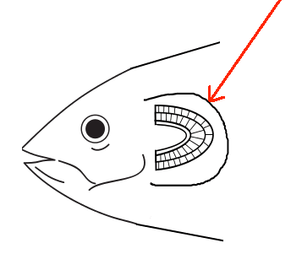

1. Gill
2. Operculum
3. Gill Arch
4. Gill Filament
5. Identify the name of the structure indicated by the red line in the picture below.

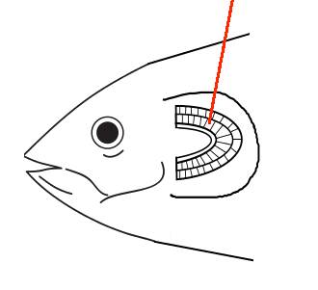

1. Gill
2. Operculum
3. Gill Arch
4. Gill Filament
5. Identify the name of the structure indicated by the red line in the picture below.

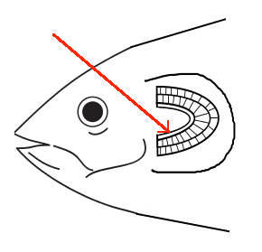

1. Gill
2. Operculum
3. Gill Arch
4. Gill Filament
5. Identify the name of the structure that the green arrows are pointing to.

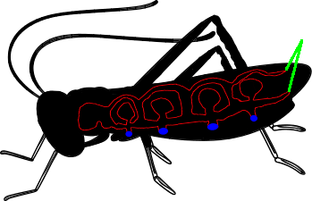

1. Trachea
2. Air Sacs
3. Bronchi
4. Spiracles
5. Identify the name of the structure that the green arrows are pointing to.

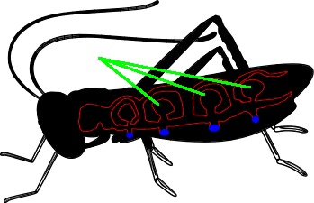

1. Trachea
2. Air Sacs
3. Bronchi
4. Spiracles
5. 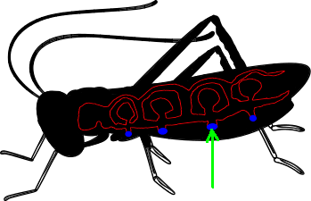Identify the name of the structure that the green arrows are pointing to.
6. Trachea
7. Air Sacs
8. Bronchi
9. Spiracles